Banking Data Platform on Google Cloud Platform
Steps to follow

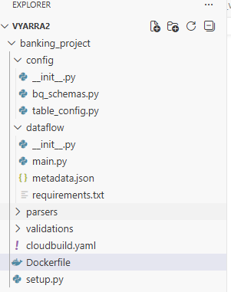

Complete code is available in Git repo:
https://github.com/venkatesh-syne/Data_Engineering/tree/data_engineering/banking_project

Cloud build.yaml
steps:

- name: 'gcr.io/cloud-builders/docker'

args:
[
'build',
'-f',
'Dockerfile',
'-t',
'us-central1-docker.pkg.dev/scenic-kiln-351104/dataflow-repo/banking-bronze:v10',
'.'
]

images:
- 'us-central1-docker.pkg.dev/scenic-kiln-351104/dataflow-repo/banking-bronze:v10'

Docker File:
FROM gcr.io/dataflow-templates-base/python311-template-launcher-base

WORKDIR /template

COPY . .

RUN pip install --no-cache-dir -r dataflow/requirements.txt

RUN pip install .

ENV FLEX_TEMPLATE_PYTHON_PY_FILE="/template/dataflow/main.py"
ENV FLEX_TEMPLATE_PYTHON_REQUIREMENTS_FILE="/template/dataflow/requirements.txt"

# IMPORTANT
ENV FLEX_TEMPLATE_PYTHON_SETUP_FILE="/template/setup.py"

ENV PYTHONPATH="/template"

from setuptools import setup, find_packages

setup(
name="banking_project",
version="1.0",
packages=find_packages(),
)

- Set Project
gcloud config set project <Project Id>
gcloud config set project scenic-kiln-351104

Verify:
gcloud config get-value project

- Enable Required APIs
gcloud services enable \
dataflow.googleapis.com \
bigquery.googleapis.com \
storage.googleapis.com \
artifactregistry.googleapis.com \
cloudbuild.googleapis.com \
composer.googleapis.com \
iam.googleapis.com

- Create Buckets
Landing Bucket
gsutil mb -l us-central1 gs://banking-landing

Dataflow Temp Bucket
gsutil mb -l us-central1 gs://banking-temp

Dataflow Staging Bucket
gsutil mb -l us-central1 gs://banking-staging

Flex Template Bucket
gsutil mb -l us-central1 gs://banking-dataflow-template
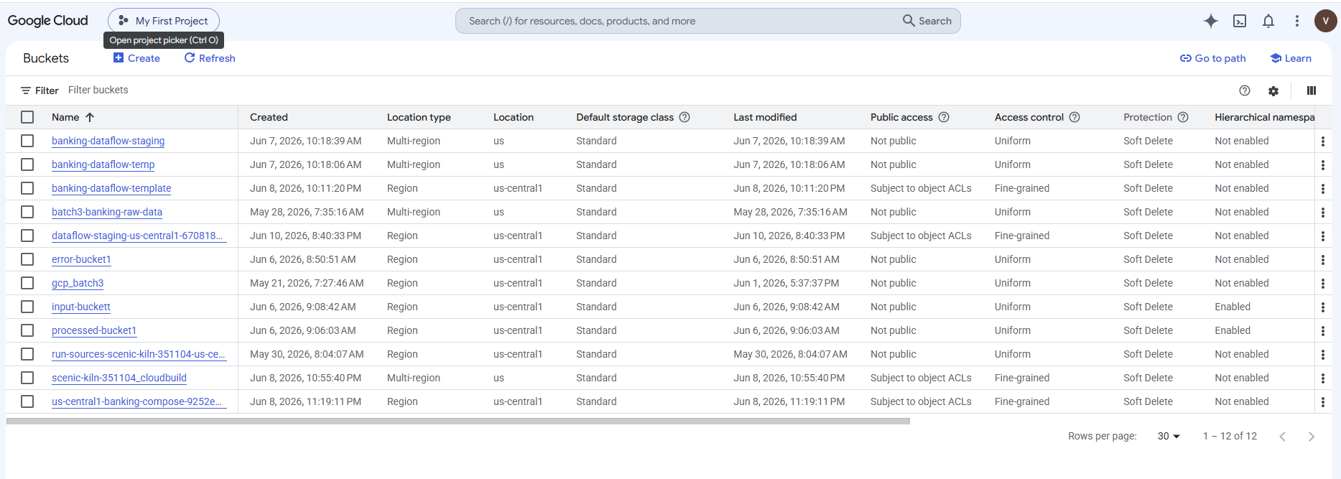

- Create Artifact Registry
gcloud artifacts repositories create dataflow-repo \
--repository-format=docker \
--location=us-central1 \
--description="Dataflow Images"

Verify:
gcloud artifacts repositories list
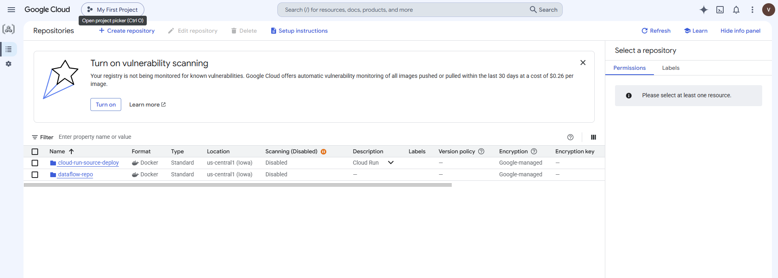

5. Configure Docker
gcloud auth configure-docker us-central1-docker.pkg.dev

6. Create Service Account
gcloud iam service-accounts create dataengineer \
--display-name="Data Engineer"

7. Grant Roles
gcloud projects add-iam-policy-binding scenic-kiln-351104 \
--member="serviceAccount:dataengineer@scenic-kiln-351104.iam.gserviceaccount.com" \
--role="roles/dataflow.admin"
gcloud projects add-iam-policy-binding scenic-kiln-351104 \
--member="serviceAccount:dataengineer@scenic-kiln-351104.iam.gserviceaccount.com" \
--role="roles/storage.admin"
gcloud projects add-iam-policy-binding scenic-kiln-351104 \
--member="serviceAccount:dataengineer@scenic-kiln-351104.iam.gserviceaccount.com" \
--role="roles/bigquery.admin"
gcloud projects add-iam-policy-binding scenic-kiln-351104 \
--member="serviceAccount:dataengineer@scenic-kiln-351104.iam.gserviceaccount.com" \
--role="roles/artifactregistry.writer"
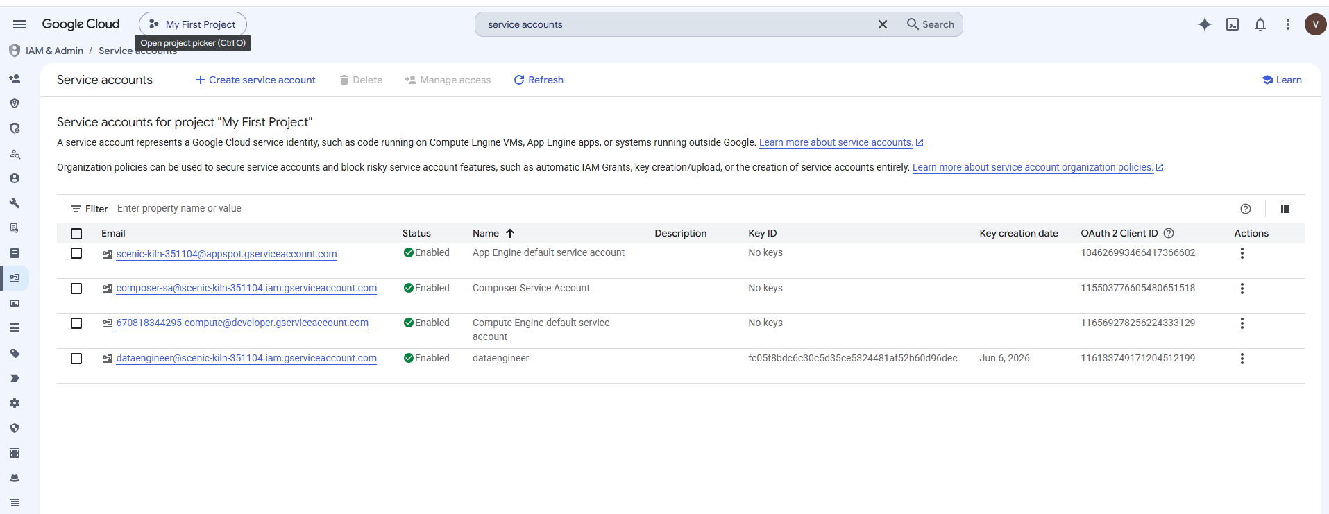

8. Create BigQuery Datasets
Bronze
bq mk --dataset scenic-kiln-351104:banking_bronze
Silver
bq mk --dataset scenic-kiln-351104:banking_silver
Gold
bq mk --dataset scenic-kiln-351104:banking_gold
Audit
bq mk --dataset scenic-kiln-351104:audit

9. Build Docker Image
From project root:
gcloud builds submit \
--tag us-central1-docker.pkg.dev/scenic-kiln-351104/dataflow-repo/banking-bronze:v1
Verify:
gcloud artifacts docker images list \
us-central1-docker.pkg.dev/scenic-kiln-351104/dataflow-repo 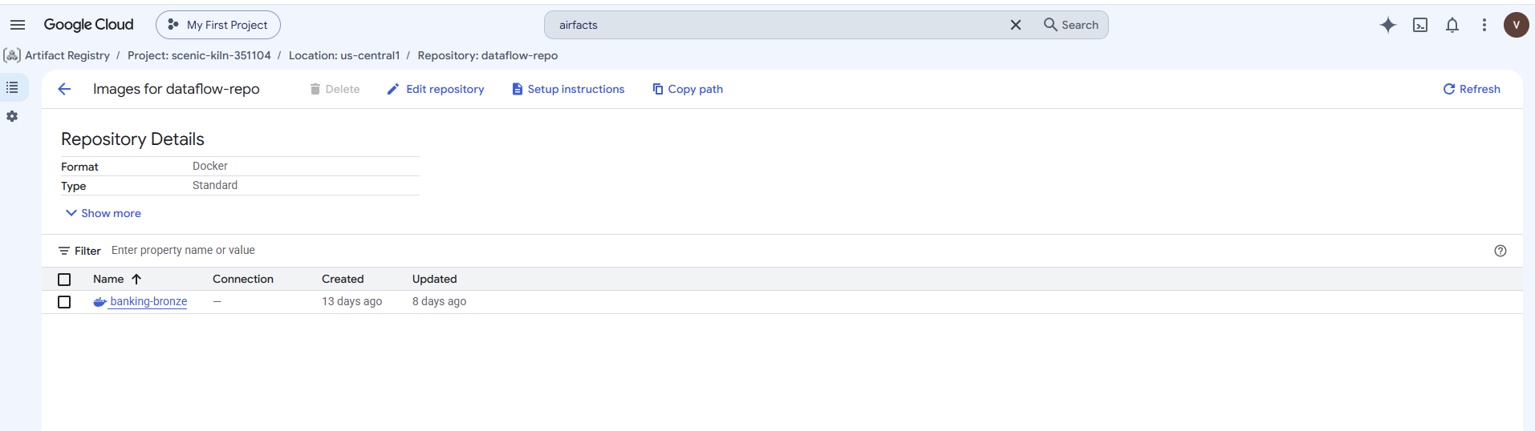
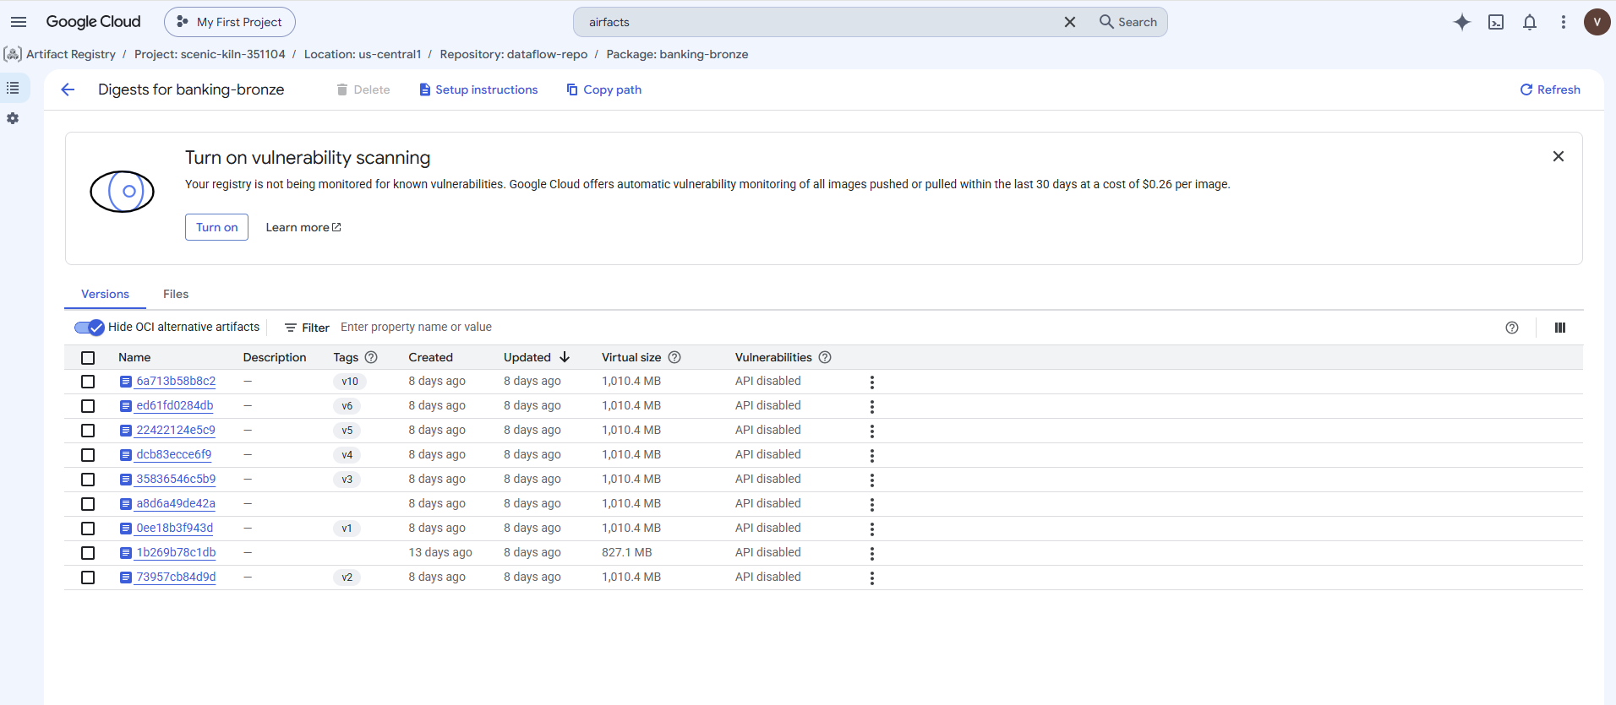

10. Build Flex Template
gcloud dataflow flex-template build \
gs://banking-dataflow-template/banking-bronze.json \
--image=us-central1-docker.pkg.dev/scenic-kiln-351104/dataflow-repo/banking-bronze:v1 \
--sdk-language=PYTHON \
--metadata-file=dataflow/metadata.json
Verify:
gsutil ls gs://banking-dataflow-template 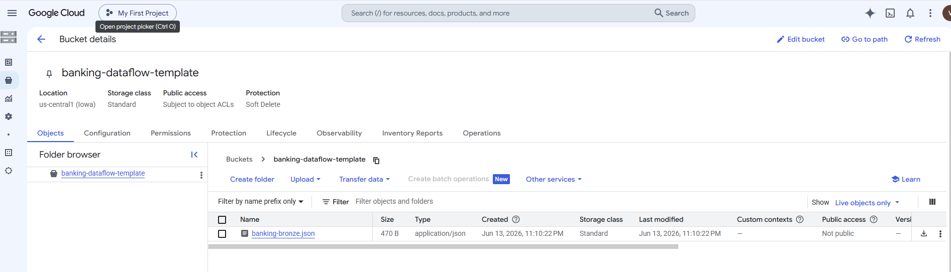

11. Trigger Flex Template
gcloud dataflow flex-template run banking-bronze-$(date +%s) \
--template-file-gcs-location gs://banking-dataflow-template/banking-bronze.json \
--region us-central1 \
--parameters=batch_id=TEST001

12. Create Audit Table
CREATE TABLE audit.job_audit
(
batch_id STRING,
job_name STRING,
start_time TIMESTAMP,
end_time TIMESTAMP,
status STRING,
source_count INT64,
target_count INT64
);

13. Create Reconciliation Table
CREATE TABLE audit.reconciliation
(
batch_id STRING,
table_name STRING,
source_count INT64,
target_count INT64,
status STRING,
reconciliation_time TIMESTAMP
);

14. Create Audit Procedures
Start Procedure
CREATE OR REPLACE PROCEDURE audit.sp_audit_start(...)
End Procedure
CREATE OR REPLACE PROCEDURE audit.sp_audit_end(...)

15. Create Silver Stored Procedure
CREATE OR REPLACE PROCEDURE banking_silver.sp_bronze_to_silver()
BEGIN
...
END;

16. Create Gold Stored Procedure
CREATE OR REPLACE PROCEDURE banking_gold.sp_silver_to_gold()
BEGIN
...
END;

17. Create Composer Service Account
gcloud iam service-accounts create composer-sa

18. Create Composer Environment
gcloud composer environments create banking-composer \
--location us-central1 \
--image-version composer-3-airflow-2.10.5 \
--service-account composer-sa@scenic-kiln-351104.iam.gserviceaccount.com
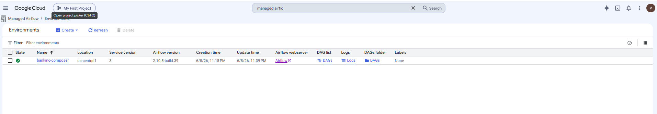

19. Get Composer Bucket
gcloud composer environments describe banking-composer \
--location us-central1
Copy:
gs://<composer-bucket>
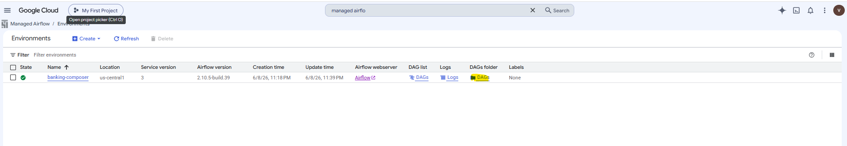

20. Upload DAG
gsutil cp dags/banking_pipeline.py \
gs://<composer-bucket>/dags/
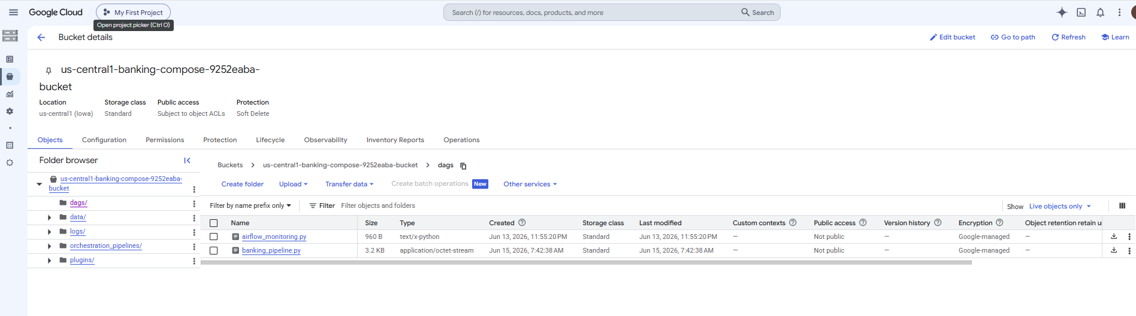

21. Verify DAG
gcloud composer environments run banking-composer \
--location us-central1 dags list 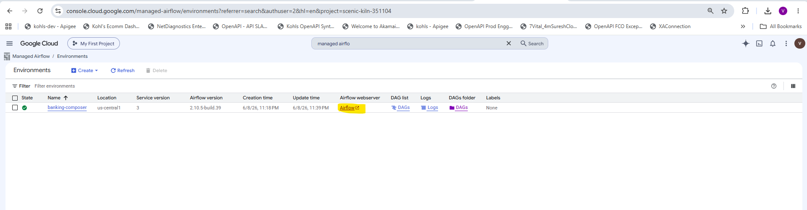
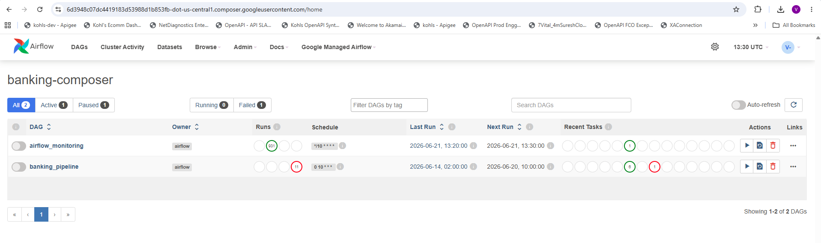

22. Monitor Dataflow
gcloud dataflow jobs list \
--region us-central1
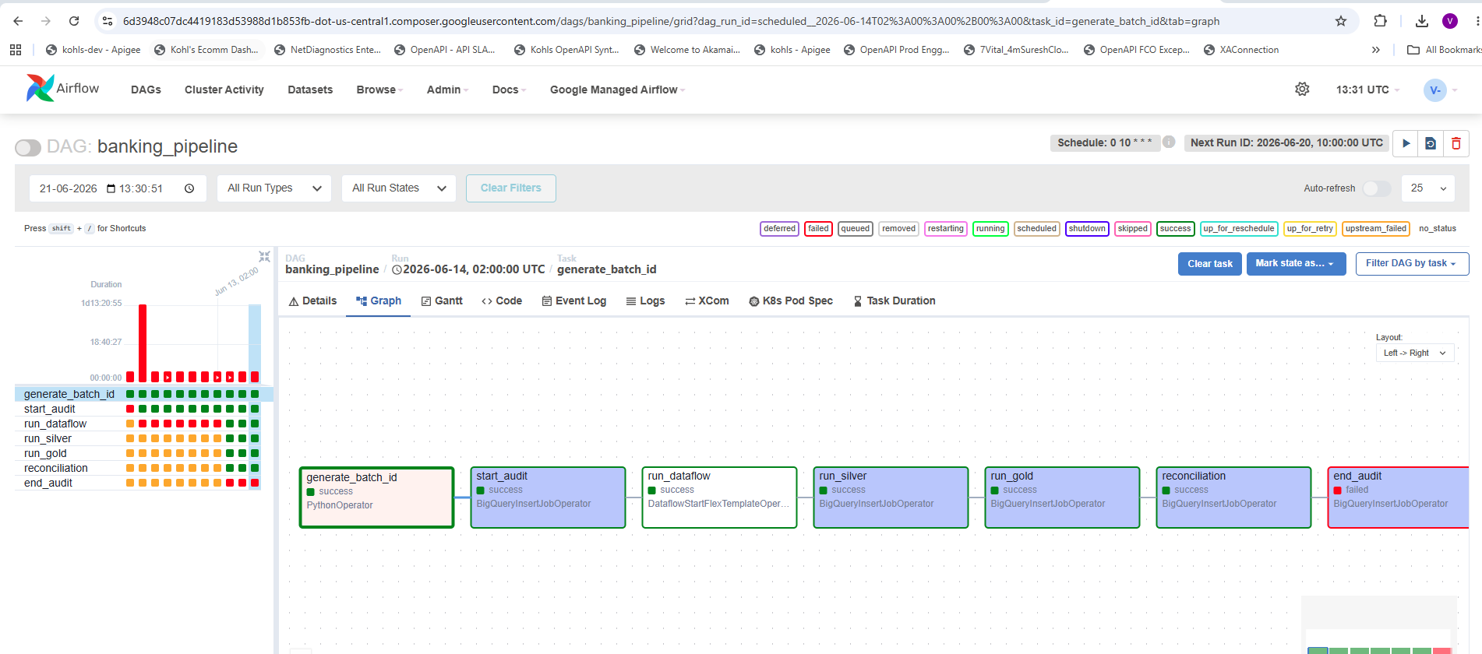
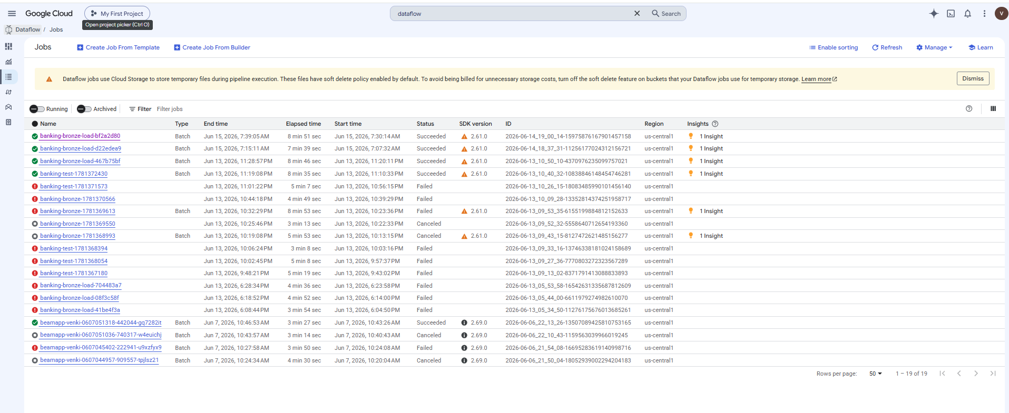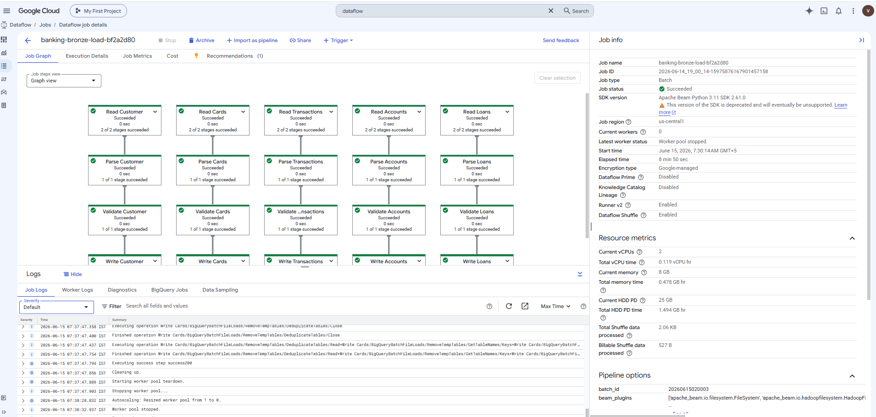

23. Monitor Composer
gcloud composer environments run banking-composer \
--location us-central1 dags state banking_pipeline


24. Check Audit
SELECT *
FROM audit.job_audit
ORDER BY start_time DESC;

25. Check Reconciliation
SELECT *
FROM audit.reconciliation
ORDER BY reconciliation_time DESC;
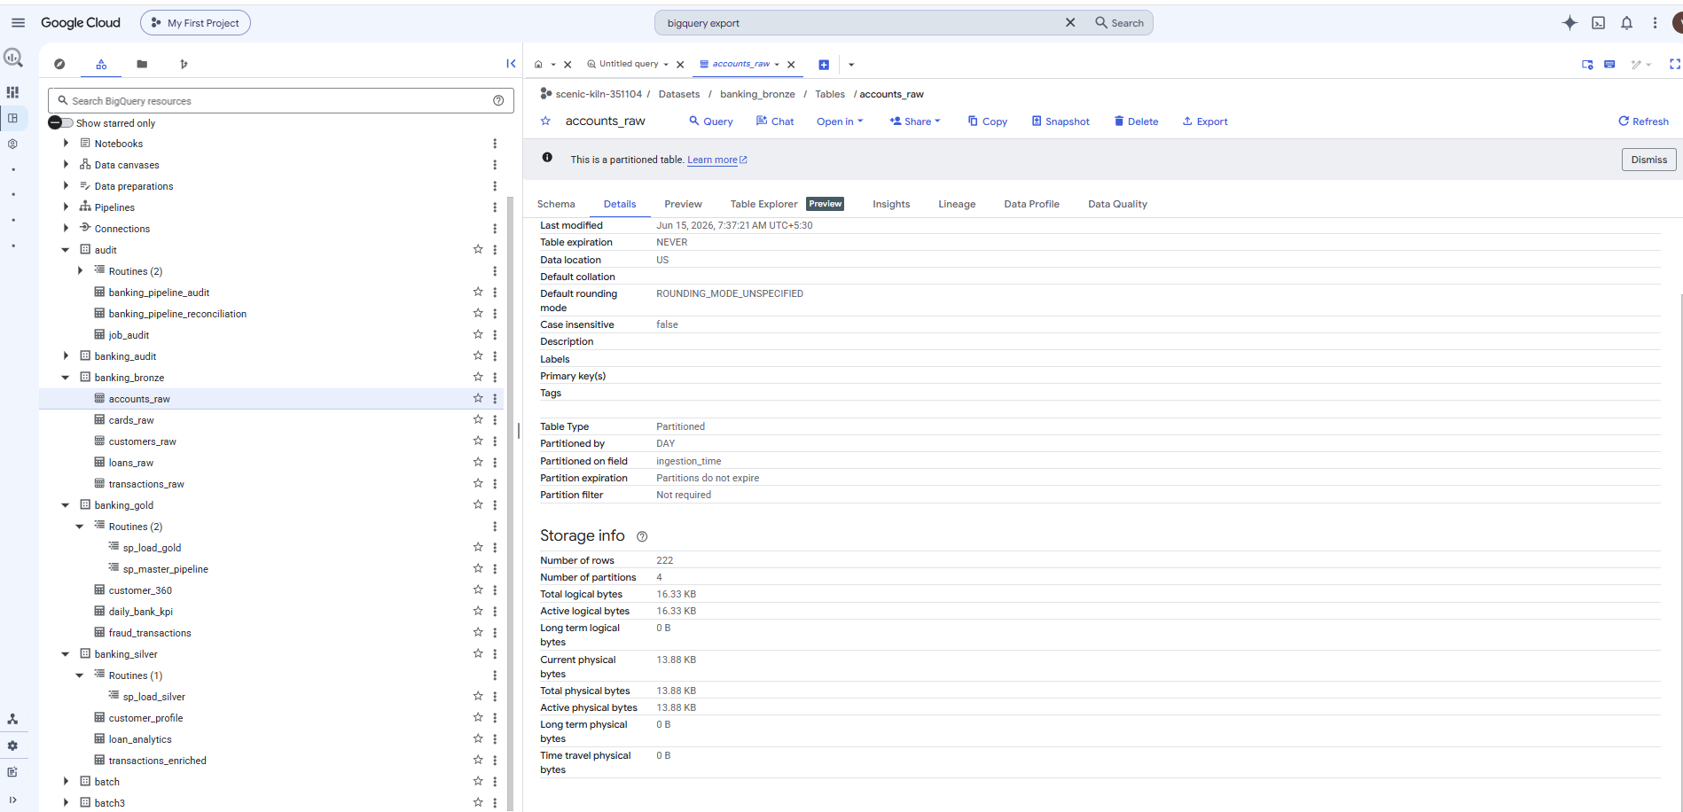

Final Production Flow
CSV Files
│
▼
Cloud Storage
│
▼
Cloud Composer
│
▼
Dataflow Flex Template
│
▼
BigQuery Bronze
│
▼
sp_bronze_to_silver
│
▼
BigQuery Silver
│
▼
sp_silver_to_gold
│
▼
BigQuery Gold
│
▼
Reconciliation
│
▼
Audit End
│
▼
Looker / Tableau / Power BI

